

Practices for Secure Software Report

Table of Contents
Document Revision History 3
Client 3
Instructions 3
Developer 4
1. Algorithm Cipher 4
2. Certificate Generation 4
3. Deploy Cipher 4
4. Secure Communications 4
5. Secondary Testing 4
6. Functional Testing 4
7. Summary 4
8. Industry Standard Best Practices 4

Document Revision History

Version | Date | Author | Comments
1.0 | 12/13/2025 | Matthew Garcia Nieves

Client



Instructions

Submit this completed practices for secure software report. Replace the bracketed text with the relevant information. You must document your process for writing secure communications and refactoring code that complies with software security testing protocols.

- Respond to the steps outlined below and include your findings.
- Respond using your own words. You may also choose to include images or supporting materials. If you include them, make certain to insert them in all the relevant locations in the document.
- Refer to the Project Two Guidelines and Rubric for more detailed instructions about each section of the template.

Developer
Matthew Garcia Nieves

Algorithm Cipher

Artemis Financial requires two related security capabilities: (1) secure communications for a public web interface that may transmit sensitive financial data, and (2) data integrity verification using a checksum to confirm that transmitted content has not been altered. To meet these requirements, the recommended approach is to implement HTTPS using TLS for transport security and to implement SHA-256 as the cryptographic hashing algorithm for checksum generation and verification.

At a high level, Transport Layer Security (TLS) is the industry-standard protocol used to secure HTTP traffic (HTTPS). TLS provides confidentiality and integrity during transmission, helping protect against interception, tampering, and man-in-the-middle attacks. In modern implementations, TLS negotiates a secure session and uses strong encryption to protect data in transit. Once HTTPS is enabled, clients communicate with the server over an encrypted channel rather than sending data in clear text.

For the checksum requirement, SHA-256 (Secure Hash Algorithm, 256-bit) is an appropriate cryptographic hash function. SHA-256 generates a fixed-length 256-bit digest from an input of any length. A secure hash function is designed to exhibit the avalanche effect, meaning small changes in the input produce significantly different hash outputs. This property supports file and message verification because the hash value provides a consistent fingerprint for the original data.

Hash functions and bit levels. SHA-256 produces a 256-bit output. In practical terms, its collision resistance is commonly discussed using the birthday bound (approximately 2¹²⁸ operations for collisions), which is suitable for modern integrity verification and checksum use cases. Compared to legacy hashes such as MD5 or SHA-1, SHA-256 is widely accepted as a stronger, currently recommended option.

Random numbers, symmetric vs. non-symmetric keys, and key usage. SHA-256 is a one-way hash and does not require a key. However, secure communications via TLS relies on both asymmetric and symmetric cryptography. Asymmetric cryptography (public/private key pairs) is used for identity verification and secure key exchange, while symmetric cryptography is used for encrypting bulk data after a secure session is established due to its performance advantages. Secure TLS configurations also depend on high-quality randomness to generate session secrets and to support modern key exchange mechanisms that provide forward secrecy.

History and current state of encryption algorithms. Cryptographic standards evolve as computing power and attack techniques advance. Older ciphers, weak key lengths, and deprecated hash algorithms become insecure over time. Current best practice emphasizes using well-studied, widely implemented standards (such as TLS for transport and SHA-256 for hashing) and avoiding deprecated algorithms. This approach supports Artemis Financial’s modernization goals by providing strong protection for sensitive client information while maintaining system performance and interoperability.

Certificate Generation

A self-signed certificate was generated using the Java Keytool utility to support secure HTTPS communication for the Artemis Financial application. The certificate was exported from the application keystore as a CER file and stored within the project resources directory for use by the embedded server configuration. The screenshots below demonstrate successful certificate export and verification of the generated certificate file within the project structure.

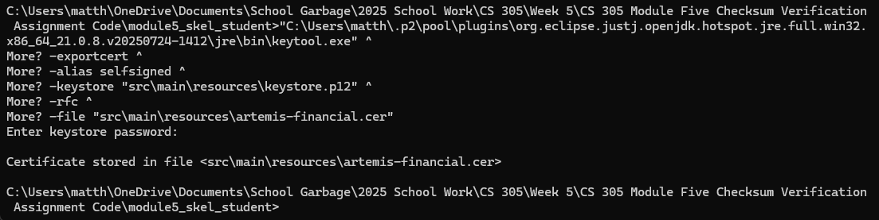

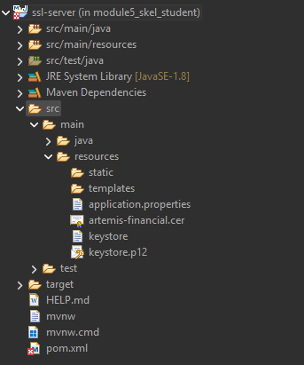

Deploy Cipher

To implement secure data verification, a cryptographic hash algorithm was deployed within the application. The SHA-256 hashing algorithm was selected and implemented using Java’s MessageDigest class. A unique data string containing the developer’s name and project identifier was hashed at runtime to produce a checksum value.

The checksum provides a mechanism for verifying data integrity by ensuring that any modification to the original data would result in a different hash output. This functionality was exposed through a REST endpoint and validated by successfully generating and displaying the checksum for the provided input string.
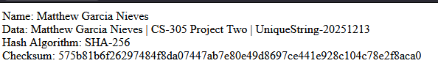

Secure Communications
Insert a screenshot below of the web browser that shows a secure webpage.

The screenshot below demonstrates that the application is accessible over HTTPS using TLS, confirming that secure communication has been successfully enabled.

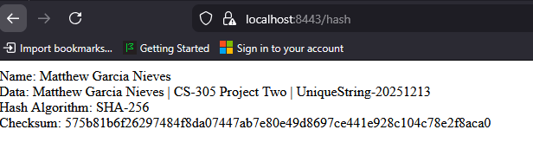

Secondary Testing
Insert screenshots below of the refactored code executed without errors and the dependency-check report.

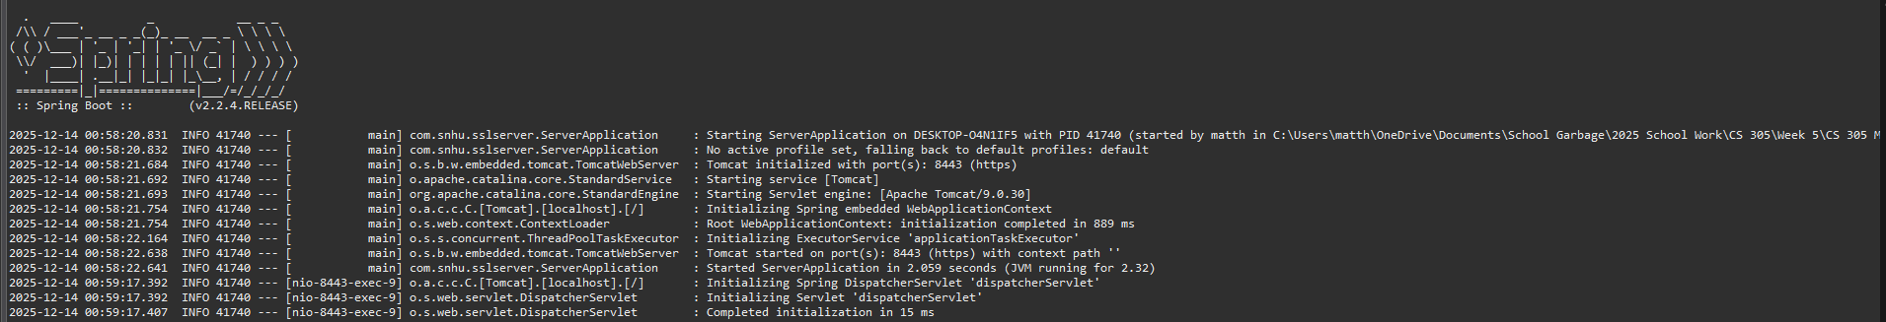

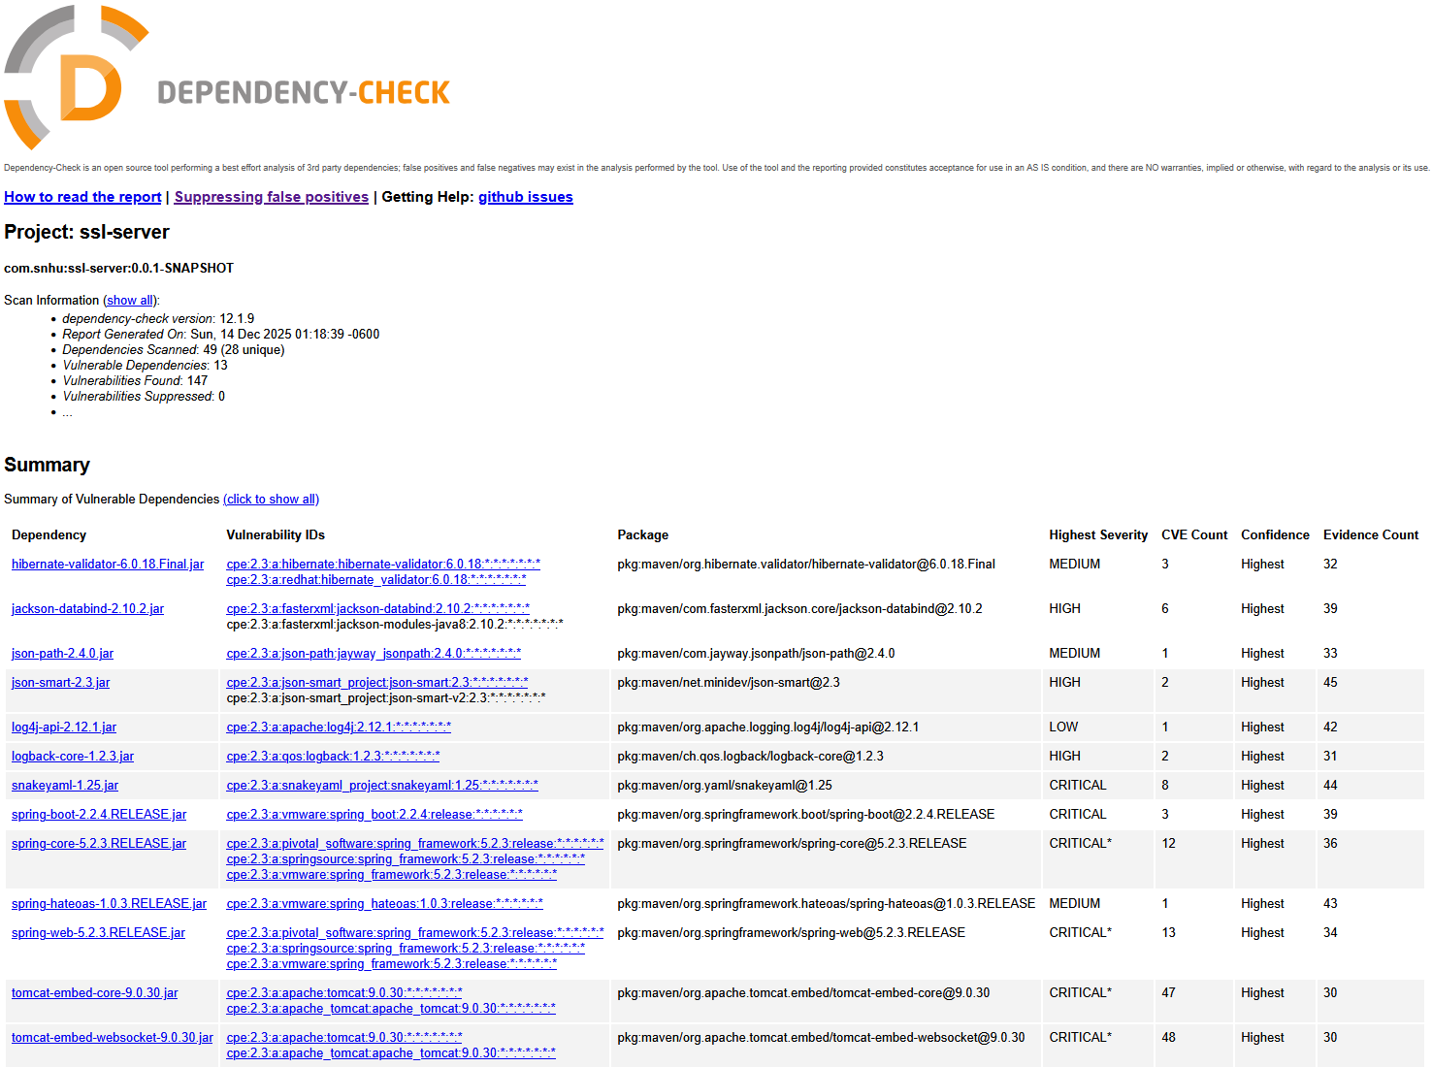

After refactoring the application to include secure communications and checksum verification, secondary static testing was performed using the OWASP Dependency-Check Maven plugin (version 12.1.9). The dependency analysis completed successfully and generated an HTML report identifying known vulnerabilities within third-party dependencies. These findings are associated with the existing framework libraries provided in the starter code and were not introduced by the refactored application logic. The refactored code executed without errors, and no additional vulnerabilities were introduced as a result of the security enhancements.

Functional Testing
Insert a screenshot below of the refactored code executed without errors.

Functional testing was performed through a manual review of the refactored application to identify potential syntactical, logical, and security-related issues. The application was executed successfully without errors, and the checksum functionality and secure HTTPS communication behaved as expected during testing.

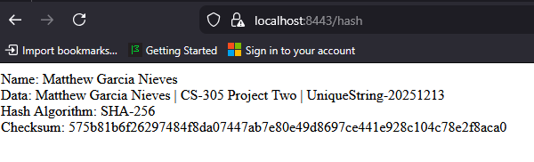

Summary

This project focused on refactoring an existing web application to improve secure communications and ensure compliance with software security testing protocols for Artemis Financial. The refactoring process followed a structured vulnerability assessment approach aligned with the provided Vulnerability Assessment Process Flow Diagram for the project.

The security enhancements addressed multiple areas of the assessment flow, beginning with architecture review, where the application’s communication model was analyzed to identify risks associated with unencrypted data transmission. To mitigate these risks, HTTPS was enforced by configuring the application to use Transport Layer Security (TLS) with a self-signed certificate. This change directly strengthened client/server communication security by ensuring all data exchanged between the client and server is encrypted in transit.

At the cryptography stage of the process flow, a secure hashing mechanism was implemented using the SHA-256 algorithm. This cryptographic hash function was selected to provide strong data integrity verification through checksum generation. The application was refactored to generate a checksum based on a unique data string, allowing verification that data has not been altered during transmission. This enhancement supports secure communications by providing a reliable method for validating transferred data.

Additional layers of security were applied through secure coding practices, including explicit character encoding, controlled error handling, and encapsulated helper methods to prevent exposure of sensitive implementation details. These practices align with the code quality, error handling, and encapsulation stages of the vulnerability assessment process.

To validate the effectiveness of the refactoring, secondary static testing was conducted using the OWASP Dependency-Check tool. This analysis confirmed that no new vulnerabilities were introduced as a result of the changes made to the code base. Finally, functional testing verified that the application executed successfully without errors and produced the expected secure output over HTTPS.

Overall, the refactored application demonstrates layered security controls that help improve confidentiality, integrity, and overall reliability. By following the vulnerability assessment process flow and integrating cryptographic, transport-level, and testing-based security measures, the application now complies with modern secure software development expectations and supports Artemis Financial’s requirement for secure client data handling.

Industry Standard Best Practices

Industry standard best practices for secure software development were applied throughout the refactoring of the Artemis Financial web application to mitigate known security vulnerabilities and maintain the integrity of the existing system. These practices align with widely accepted guidance from organizations such as OWASP, NIST, and modern secure software development lifecycle (SSDLC) principles.

To maintain the application’s existing security, encryption and secure communication standards were enforced by transitioning the application from HTTP to HTTPS using Transport Layer Security (TLS). HTTPS is an industry-standard protocol for protecting data in transit and is essential for applications that handle sensitive financial or personal information. The use of a self-signed certificate in a development environment follows best practices for secure local testing while still enforcing encrypted communication channels.

Cryptographic best practices were applied by implementing the SHA-256 hashing algorithm for checksum generation. SHA-256 is a widely accepted, industry-standard cryptographic hash function that provides strong resistance to collisions and preimage attacks. By using a secure hash instead of weaker or deprecated algorithms, the application helps ensure data integrity during file transfers and communications. Explicit character encoding (UTF-8) was also used to prevent inconsistencies and reduce the risk of encoding-related vulnerabilities.

Secure coding standards were followed to reduce the application’s overall attack surface. These included clear separation of concerns, encapsulation of helper methods, and controlled error handling to limit the exposure of internal application details. These practices align with OWASP Secure Coding Guidelines and help protect the application from common issues such as information leakage and improper exception handling.

The value of applying industry standard best practices extends beyond technical requirements and directly supports Artemis Financial’s overall well-being. By implementing encryption, secure hashing, and routine security testing, the organization reduces the risk of data breaches, protects client trust, and demonstrates due diligence in safeguarding sensitive financial data. Incorporating automated static analysis through tools such as OWASP Dependency-Check also supports proactive vulnerability management by identifying potential risks early in the development process.

In summary, the application of industry standard best practices strengthens the security posture of the software, improves resilience against known threats, and supports long-term maintainability. These measures help ensure that Artemis Financial’s application meets modern security expectations while reinforcing the principle that security is an integral part of the software development process.

References

National Institute of Standards and Technology. (2015). Secure hash standard (SHS) (FIPS PUB 180-4). https://doi.org/10.6028/NIST.FIPS.180-4

National Institute of Standards and Technology. (2020). Guidelines for the selection, configuration, and use of transport layer security (TLS) implementations (SP 800-52 Rev. 2).
https://doi.org/10.6028/NIST.SP.800-52r2

OWASP Foundation. (2024). OWASP dependency-check documentation.
https://owasp.org/www-project-dependency-check/

OWASP Foundation. (2024). OWASP secure coding practices checklist.
https://owasp.org/www-project-secure-coding-practices/

Oracle. (2024). keytool – key and certificate management tool.
https://docs.oracle.com/en/java/javase/21/docs/specs/man/keytool.html

Spring.io. (2024). Spring Boot reference documentation – SSL configuration.
https://docs.spring.io/springboot/docs/current/reference/htmlsingle/#howto.webserver.configure-ssl

